**SQL USE CASE:**

A XYZ corporation is a organization where they are designing database as per the requirement below cases should be satisfied.

**ER Diagram:**

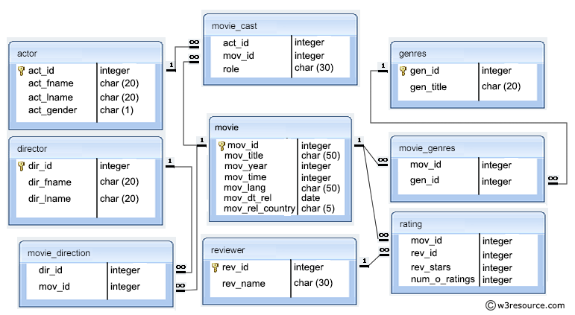

Actor Director

Genres Movie_cast

Movie

Movie_direction Movie_genres

Rating Reviewer

**Section A**

1. Create Database project_movie_data and deploy table data according to ER diagram.
2. Create 9 tables which are presented in ER model and load the data with their foreign key and primary key values.
3. Write a query in SQL to list the Horror movies?
4. Write a query in SQL to find the name of all reviewers who have rated 8 or more stars?
5. Write a query in SQL to list all the information of the actors who played a role in the movie ‘Deliverance’
6. Write a query in SQL to find the name of the director (first and last names) who directed a movie that casted a role for ‘Eyes Wide Shut’. (using subquery)
7. Write a query in SQL to find the movie title, year, date of release, director and actor for those movies which reviewer is ‘Neal Wruck’
8. Write a query in SQL to find all the years which produced at least one movie and that received a rating of more than 4 stars.
9. Write a query in SQL to find the name of all movies who have rated their ratings with a NULL value
10. Write a query in SQL to find the name of movies who were directed by ‘David’
11. Write a query in SQL to list the first and last names of all the actors who were cast in the movie ‘Boogie Nights’, and the roles they played in that production.
12. Find the name of the actor who have worked in more than one movie.

**Section -B**

Use an appropriate combination of SQL, stored procedures and/or triggers to implement

the ability to allow programmers to cast a new actor (by ID#) to a movie (by ID#).

Do not allow actors to be cast more than once for each movie.

Demonstrate that your system works by trying the following.

Cast George Faraday (# 124) in Slumdog Millionaire (# 921).

Cast George Faraday in Back to the Future (# 928).

Cast George Faraday (# 124) in Slumdog Millionaire (# 921)

Record in the script comments what happens with each of these updates and why.